Análisis numérico térmico de la eficiencia de sellado
a una junta de motor fabricada por CRS de ¼ dureza
con un recubrimiento de nitrilo en ambos lados

Thermal numerical analysis of sealing efficiency
to an engine gasket manufactured by CRS of ¼ hardness
with a nitrile coating on both sides

Martín Guzmán-Baeza¹, Martín García-Pérez², Guillermo Urriolagoitia-Sosa³,
Beatriz Romero-Ángeles⁴, Belén Alejandra Contreras-Mendoza⁵, José Luis Reyes-Reyes⁶,
Diego Sabas-Gonzalez⁷, Antonio Hernández-Cerón⁸, Félix Omar Soto-Barrón⁹

Grupo de Biomecánica, SEPI ESIME Zacatenco, Instituto Politécnico Nacional, México.
Email; ¹maguzmanb@ipn.mx , ²mgarcia2302@hotmail.com, ³guiurri@hotmail.com,
⁴romerobeatriz97@hotmail.com, ⁵bele02mendoza@gmail.com, ⁶jreyesre@ipn.mx,
⁷dealdarken1408@hotmail.com, ⁸ahernandezc9800@alumno.ipn.mx, ⁹fosotob@ipn.mx

Resumen
Las juntas de cabeza de acero de múltiples capas son componentes de sellado pasivo importantes que existen en los motores de combustión interna y son cruciales para el rendimiento adecuado del motor. En este trabajo se propone analizar la junta de sellado con materiales compuestos (metal con recubrimiento) para garantizar la eficiencia. Los resultados de este trabajo servirán para realizar los análisis paramétricos de la fuerza de pretensado de los pernos entre el ensamblaje en frío y considerarse como una referencia de diseño para el motor de automóvil. La idea principal de este análisis numérico, es introducir el elemento de pretensión en la simulación del conjunto atornillado con los otros componentes. En comparación con el método tradicional, el elemento de pretensión tiene muchas ventajas sobre el método para controlar el aumento y la disminución de la temperatura. Asimismo, se corrobora por medio de una evaluación experimental del sistema que se está analizando numéricamente. Además, se puede concluir de manera general que la evaluación numérica es muy cercana a la realidad.

Palabras clave: Junta, sellado, evaluación numérica, contacto, esfuerzo.

Abstract
Gaskets are important passive sealing components found in internal combustion engines and crucial to proper engine performance. In this work, it is proposed to analyze the sealing gasket with composite materials (metal with coating) to guarantee efficiency. The results of this work will serve to carry out the parametric analysis of the prestressing force of the bolts between the cold assembly and be considered as a design reference for the automobile engine. The main idea of ​​this numerical analysis is to introduce the pretension element in the simulation of the bolted assembly with the other components. Compared with the traditional method, the pretension element has many advantages over the method to control the temperature rise and fall. Likewise, it is corroborated through an experimental evaluation of the system that is being analyzed numerically. In addition, it can be concluded in a general way that the numerical evaluation is very close to reality.

Keywords; Sealing, gasket, numerical evaluation, Contact, Stress.

Introduction
The internal combustion engine gained importance towards the end of the XIX century [1], due to its characteristic to potential the maximum performance limit. In addition to the fact, that this type of motor is capable of exchanging the heat it produces with the outside environment, it can be adapted to a wide range of heat sources for its operation. Being an internal combustion engine it is possible to control and efficiently reduce combustion emissions. However, the working fluid is gaseous, which causes operational difficulties. In practice, it has been seen that the viable working fluids are Hydrogen and Helium (due to their excellent thermodynamic properties) [2]. The development of technology, research, and creativity of the human being in the last century have provided the basis for the optimization of this type of engine, which does add to the increase in the knowledge of fuels, and this provides a substantive advance when are used for transport. The early start was founded by; Eugenio Barsanti and Felice Matteucci [3], Alphonse Beau de Rochas [4], Nicolaus Otto [5], Rudolf Diesel [6] among others. Nonetheless, the development of fuels has had a great impact on the development and evolution of the engine. For example, during World War I, fuels with better antiknock properties were developed on a large scale [7]. On the other hand, during the past three decades, it has sought to improve engine performance, control polluting emissions, and reduce fuel consumption. Internal combustion engines are a major source of noise (exhaust system, intake system, the fan used for engine cooling, and the engine cylinder head, to mention some examples). Noise can be generated by the internal combustion process [8-9]. The internal combustion engine has improved a lot since its beginning, the performance of engines has improved from a 10% efficiency that reached the first engines, up to 35-40% nowadays. Additionally, with the application of new technologies, improvements in fuels, materials, etc. have permitted to achieve great power [10-11]. The purpose in the evolution of internal combustion engines is to optimize their operation, which is possible by improving each of its systems. The sealing of the combustion chamber is an important proposal which could be address by the development of new devices.

Currently, in the Automotive Industry there is a great variety of approaches to analyze and evaluate all types of components, so numerical analysis (Finite Element Method) is very useful [12-15]. Vast resources have been invested in the design and manufacture of engine head gaskets, where one of the most viable options is engine head gaskets made of multilayer steel (MLS). These are important passive sealing components that exist in almost all internal combustion engines and are crucial for a proper engine performance [16]. Regarding the development of gaskets for components, they are the oldest method devised produced by mankind to guarantee the water sealing by that is tightness hermeticity in equipment or facilities that work with fluids [17]. Both the Sumerians and Egyptians implemented a kind of twisted linen braid, which they covered with animal fat. This was placed in the hydraulic works to try to seal the water leaks [18]. Later in history, a great diversity of materials has been used to make seal, as they are; tow, Iron, Aluminum, bronze, Copper, sulfur powder and water to form a solid seal, Iron sulfate, pieces of rope, graphite, leather, rubber, asphalt, oil, asbestos, graphite, coal, etc. [19-22]. Today, engine head gaskets are made from a wide variety of materials including paper, rubber, silicone, metal, cork, neoprene, nitrile rubber, fiberglass, and plastic polymers [23]. Multi-Layer Steel (MLS) gaskets play an essential role in today's sealing industry for internal combustion engines. MLS type gaskets consist of multiple layers of metal (Figure 1a) [24] and contains various sealing elements. The combustion seal is the one that seals the periphery of the upper part of the monoblock cylinder with the assistance of the ribbed seals, which seal the antifreeze fluid and oil passages (Figure 1b) [25].
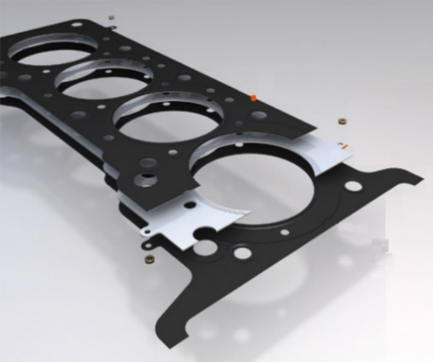
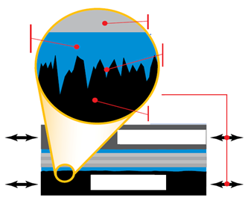
Top layer
Rivet
Middle layer
Bottom layer
a)
FKM or NBR
covering
seals rough surfaces
Steel laminate
Superficial finish; 0.0007”
Sliding surfaces
Superficial finish
Cylinder head
Engine block
b)
Figure 1. Gasket construction. a) Multi-Layer Steel gasket. b) Micro-sealing

Now a day, Engineers rely more on numerical analysis studies through the Finite Element Method to improve the design of engine components and reduce the total production time of automobile components [26-27]. Finite Element Analysis is a powerful tool used by Engineers and Designers to determine how a part or assembly performs, when subjected to various conditions. Some of the parameters that can be determined are stresses, strains, displacements and thermal expansions [28]. This research is about the efficiency of an engine gasket sealing and the stress-strain behavior of a cylinder head, applying contact theory, which are analyzed under cold starting conditions. The results of this work will be used to carry out the parametric analyzes of pre-stressing forces of the bolts between the cold assembly to be considered as a design reference for the automobile engine. Likewise, the study will focus on the engine head gasket and its interaction with the block and the head or cylinder under normal working conditions. As the engine block is the largest part of the system, the cylinders and pistons are installed there. Also, the connecting studs with the cylinder head or engine gasket are installed and the lubrication and cooling circuits pass. The materials used in block must be able to resist high temperatures, since the gas expansion and exhaust process is carried out here, it is generally built in Iron with Aluminum alloys (Figure 2) [18-21].
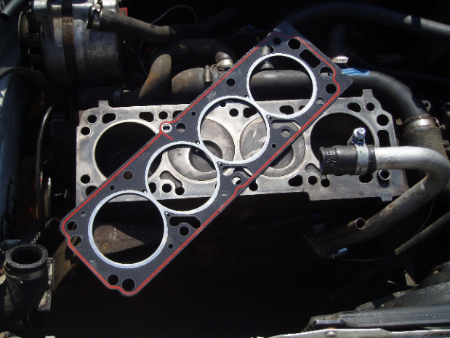
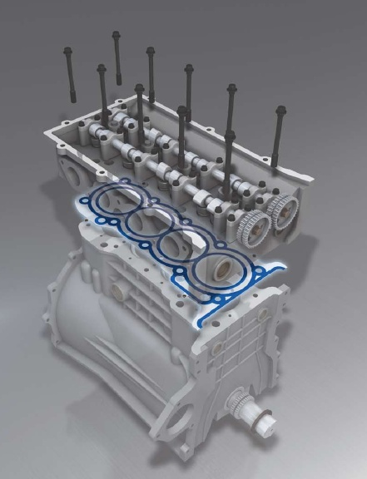
Figure 2. Head gasket in a combustion engine

2. Methodology and development
Gaskets for engines are designed, manufactured and evaluated in a very unique way, as each type of engine requires a specific and unique head gasket design. The head gasket must maintain the seal around the combustion chamber at maximum operating temperature and pressure. The gasket should be sealed against air, coolants, combustion and engine oil, considering the respective maximum operating temperatures and pressure (Figure 3).The model of the elbow was develop through computerized axial tomography. A computer program called Simpleware ScanIP® was apply to carry out the construction of the elbow model (Figure 1). This program offers the implementation of 3D models using DICOM (Digital Imaging and Communication On Medicine) images. Which generates STL files offering a wide selection of computational tools to observe images or generate 3D files. The materials used for the manufacture of the engine head gasket must cover thermal considerations and should be able to endure chemically conditions derived from combustion products. As well as, the various chemical products (coolants and oils used in the engine) [16]. When assembled, the head gasket becomes an important part of the overall engine structure, supporting the cylinder head along with its operating components [29]. To perform the numerical analysis of the gasket, the cover type and motor model were considered. Which were simplified, eliminating radius and curves, to help the convergence in the simulation (Figure 4).

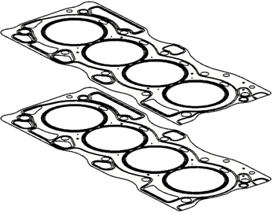
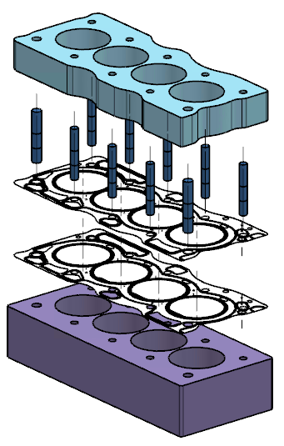
Top layer
Two layers of NBR 0.0254 mm (0.001”) and at the middle a CRS ¼ hard 0.2032 mm (0.008”)

Bottom layer
Two layers of NBR 0.0254 mm (0.001”) and at the middle a CRS ¼ hard 0.2032 mm (0.008”)
Figure 4. 2.5 L MLS gasket components
Motor´s cover
Clamping bolts
Top layer
Bottom layer
Monoblock
Figure 3. General representation of the gasket with motor´s cover and monoblock

MLS type engine gasket is widely adopted due to its good compression recovery performance, high temperature resistance and small bolt tightening force. The typical structure of the MLS gasket generally contains the upper gasket and the lower gasket [30]. Each of these gaskets (upper and lower) are configured as if it were a sandwich with two layers of NBR on each surface and in the center a sheet of CRS ¼ hard (Figure 4). The function of the upper and lower layers is to seal the motor head, where the main ribbed are distributed. In addition, to adjusting the distribution of the pre-tightening force produced by the bolt in the motor head, due to the high working pressure, high service temperature, low pre-tightening force and small sealing areas, with severe thermal load, the varied bead is designed to implement reliable sealing in any operating condition [30]. As the first stage of the numerical analysis, solid models were used for the screws, cover and motor head. Likewise, layer models for the gaskets (lower and upper), eliminating all other engine components, with which it is possible to decrease the analysis time and reduce the computational resource. In addition, a structural analysis with a static principle is considered to determine the stresses and strains acting into the gasket. However, the elasto-plastic properties of the gasket are applied, in case the load causes the yielding of the material.

3. Model generation and initial peripheral stages
Firstly, it is stipulated that the numerical simulation will be developed in a structural way and generating a 3D geometry (considering 6 degrees of freedom (UX, UY, UZ, Rot x, Rot y, Rot z)). A high order tetrahedral shell element (Solid 186, 20 nodes) is applied to discretize the gasket [30-32]. While the monoblock and the engine cover are considered as rigid bodies, applying contact theory, which will allow less computational time and concentrate the study on the head gasket. The size of the elements must be conforming to the geometric characteristics of the work piece and the gradients of the process variables for each step of the manufacturing process [30]. For this case, a tetrahedral mesh of 4 mm elements was considered with 161 032 nodes and 91 703 elements (Figure 5).

4. Mechanical properties of the materials to be used
In Figure 4, the main parts of the MLS gasket are shown, as well as, the type of material assigned for each part [33]. The two components that make up the gasket are made of ¼ hardness CRS, with a nitrile coating on both sides (NBR), with which micro-sealing is guaranteed. Table 1 shows in a general way the elastic mechanical properties of the gasket that were used for this type of analysis. However, to carry out the most complete numerical evaluation and verify that no significant permanent deformations are produced into the gasket, the properties of the plastic zone of both materials (NBR75 and CRS ¼ hard) are introduced. This information is entered in table 2. For the NBR75 material it is specified as a non-rigid (ductile) rubber, while for CRS ¼ hard (as it is a steel), initially the yield stress is stipulated and then the plastic working area of the component is delimited (Figure 6).

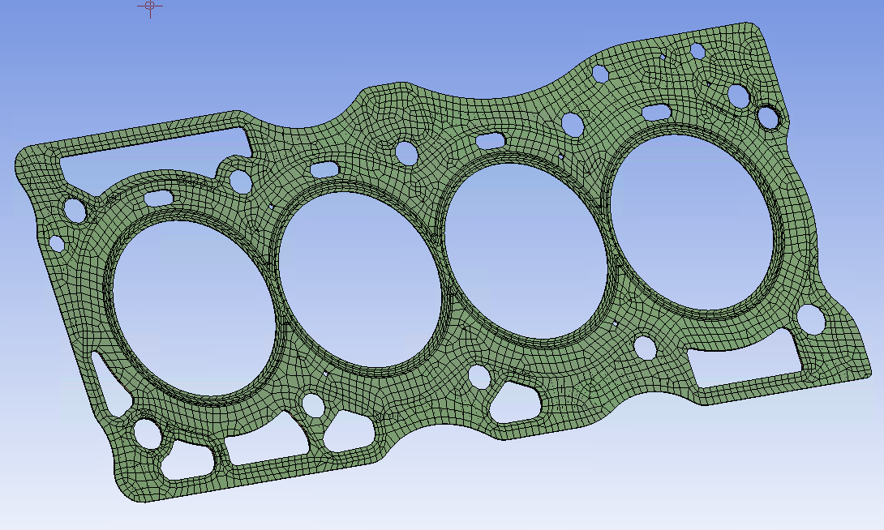
Figure 5. Gasket layer discretization

Table 1.- Basic elastic properties for the gasket components
Gasket layer | Material | Thickness (mm) | Young´s modulus
Top | NBR75 | 0.0254 | 5.8 MPa
Middle | CRS ¼ Hard | 0.2032 | 190 GPa
Bottom | NBR75 | 0.0254 | 5.8 MPa

Table 2.- Materials stress-strain data
 | NBR75 |  | CRS ¼ hard
No. | Strain (mm x 10⁻¹) | Stress (MPa) | Plastic strain (in x 10⁻¹) | Stress (psi)
1 | 0.001171 | 0.034477 | 0 | 50555
2 | 0.003122 | 0.070269 | 0.0004 | 60198
3 | 0.004782 | 0.1064 | 0.0009 | 70047
4 | 0.006343 | 0.1434 | 0.0013 | 75175
5 | 0.008002 | 0.18182 | 0.0017 | 80100
6 | 0.009954 | 0.22127 | 0.0023 | 86051
7 | 0.01132 | 0.26118 | 0.0033 | 91793
8 | 0.013077 | 0.29914 | 0.0043 | 95189
9 | 0.014638 | 0.3386 | 0.0053 | 97121
10 | 0.016395 | 0.37828 | 0.0063 | 98050
11 | 0.018347 | 0.41841 | 0.0074 | 98809
12 | 0.020299 | 0.45781 | 0.0084 | 99194
13 | 0.022055 | 0.49617 | 0.0093 | 99215
14 | 0.024007 | 0.53345
0 0.05 0.1 0.15
Strain (mm x 10⁻¹)
Stress (MPa)
2.5
2.0
1.5
1.0
0.5
0.0
a)
Coefficent of termal expansión; 0.00023
Reference temperature; 22 ºC
Material constant C 10; 8.0953 x 10⁵ Pa
Material constant C 01; 3.8713 x 10⁵ Pa
Incompressible parameter D1; 1.5448 x 10⁸ Pa-1
0 0.002 0.004 0.006 0.008 0.01
Plastic strain (in x 10⁻¹)
Stress (x 10⁵ psi)
1.0
0.8
0.7
0.6
0.5
Density; 0.2836 lb-in⁻³
Coefficient of termal expansión; 6.666 x 10⁻⁶ R⁻¹
Poisson´s ratio; 0.3
Young´s modulus; 2.05 x 10⁵ MPa
Shear modulus; 1.1436 x 10⁷ psi
Bulk modulus; 2.4777 x 10⁷ psi
Tensile and compressive yield strength; 90000 psi
Tensile ultimate strength; 99215 psi
b)
Figure 6. 2.5 L MLS material characteristics. a) NBR75 stress-strain graph and supplementary data. b) CRS ¼ hard stress-strain graph and supplementary data.

The simulated numerical behavior of the motor head gasket is considered to be elasto-plastic (represented by a bilinear behavior with kinematic hardening) [34]. The representation of the gasket materials is carried out by means of coatings, for which the modeling solution is applied in layers (Figure 6) [35-36]. The motor head, monoblock and the screws are rigid according to contact theory, so it is only necessary to apply the Young's modulus into the numerical system for each component (Table 3). With this, the numerical analysis focuses on the behavior of the head gasket. The behavior of the system is expected to be linear-elastic, however, the conditions exist to obtain elastic-plastic effects, if the application of external agents produces them. Due to the price or weight advantage of non-metals (polymers, woods, composites, etc.) over metals, non-metals are replacing metals for a variety of applications, which have a non-linear load for the characteristics of response, even under moderate loading conditions [35].

Table 3. Mechanical properties
Component | Material | Young´s modulus | Poisson ratio
Engine head | Aluminum | 72.4 GPa | 0.3
Monoblock | Gray iron | 116 GPa | 0.3
Screws | Carbon steel 45 | 210 GPa | 0.29

5. Boundary conditions and application of the external agent
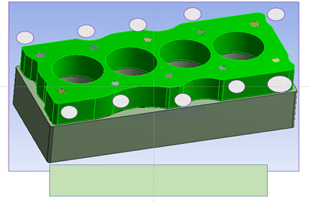
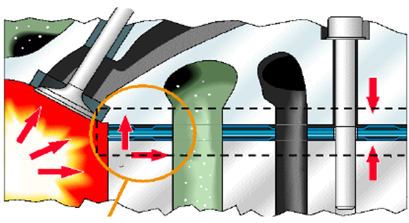
The boundary conditions applied to the motor head gasket sealing system include the displacement limit condition, the contact limit condition and the load limit condition [34]. With respect to the conditions of the displacement limit and according to the actual mounting conditions, six degrees are restricted in all directions (3 DOF of translation of X, Y and Z. As well as, the 3 DOF of rotation in XY, YZ and XZ planes) on the lower surface of the engine block (Figure 7) [34]. Correspondingly, for the contact boundary condition it is assumed that, at a certain scale, the contact surfaces between the cylinder head, the bolts and the gasket could not be completely flat. During assembly, intermetallic contact is produced at the rough edges across the surfaces. Initially, the cylinder head gasket goes through an elasto-plastic deformation process until the full contact force is supported. The size of the region of the plastically deformed gasket is directly proportional to the contact pressure and inversely proportional to the hardness of the material [34]. Generally speaking, penalty methods such as Lagrange multiplier methods and augmented Lagrangian method are widely used in numerical simulations by the Finite Element Method applying mechanical contact. However, penalty methods suffer from a poor conditioning that worsens as penalty values increase. The Lagrange multiplier method introduces additional unknowns and the resulting equation system is not necessarily positive-definite. Augmented Lagrangian method combines the penalty methods and the Lagrange multiplier methods and inherits the advantages of both methods [37]. The main benefit of the augmented Lagrange method for the contact problem is that it provides the robustness and stability of the penalty method. It is a simple procedure that does not involve additional equations for the discrete system. To accurately simulate the contact behavior between cylinder head and gasket under various engine operating conditions, the augmented Lagrangian method is adopted in Finite Element Method analysis [38]. The largest percentage of the load applied into the engine is the mounting load. This mainly refers to the pre-stressed condition of the bolts, which play an important sealing role in preventing gas escaping from the internal part of the engine. In this sense, to avoid insufficient gasket sealing, the bolts are pre-stressed into the range of 28-80 kN. Furthermore, the displacements of the nodes at the lower part of the block are considered fixed, to avoid rigid body movement (Figure 8) [38]. The initial effects that occur into the gasket depends directly on the tightening of the screws to close the motor, which is responsible to achieve the perfect seal into the system. Therefore, a force of 80 kN was applied during the tightening for each of the screws in the monoblock assembly. In the specific case of the system to be analyzed, a total of 10 screws are used to tighten the gasket. Consequently, the total force exercised in the engine and gasket system is 800 kN.
9
5
1
4
8
7
3
2
6
10
1 to 10 bolt tightening sequence
Individual tightening magnitude of 80 kN
Figure 8.- Engine head bolt tightening sequence
Refrigerant
P = +3 bar
T = 30 a 125 °C
Oil;
Cold pressure; 10-12 bar,
Temperature; 30 a 120 °C
Bolt applied load
80 kN
Combustion chamber;
Pressure; +160 bar,
Temperature; 200 a 300 °C
Movement and oscillation
Covert
MLS
Monoblock
P and T
s
F y s
Figure 9. Installation conditions and functional specifications of head gaskets
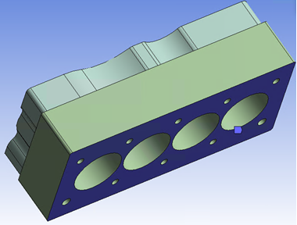
U_{x} = U_{y} = U_{z} = 0
Rot_{x} = Rot_{y} = Rot_{z} = 0
Figure 7. Boundary conditions into the system

The combustion process has a particular behavior, which depends on maximum pressure, temperature, gasket and monoblock materials (bolts, force, location, etc.) and guarantee, at all times the mainly safe sealing.

In Figure 9 and only as information, since a thermo-mechanical analysis will not be performed in this evaluation, all the requirements the engine gasket must meet are shown.

6. Model solution
At this stage, the desired results of the analysis are defined and the solution is activated. The stresses within the cylinder head gasket are the result of external agents acting on the gasket surface (called surface forces) and forces acting on the entire volume (called body forces). Under the influence of the applied forces, the gasket will shift. The gasket is assumed to behave elastically and returns to its initial configuration when applied loads are removed. A measure of the relative elongation of the solid body is known as strain and the applied load is 80 kN [39].

7. Results
Basic results are presented in the manner of von Mises stresses and contact between layers.

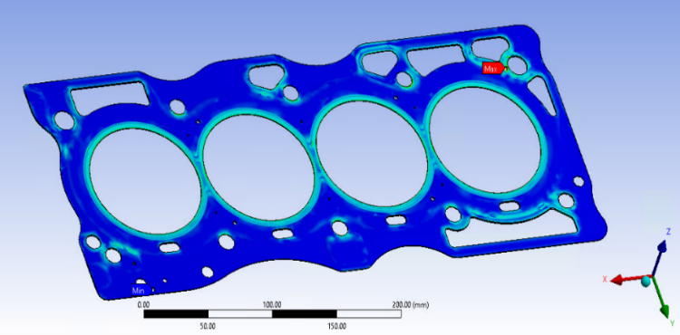
0.018133 (MPa)
0.0161216

0.01411
0.012098
0.010086
0.00807427

0.0060624
0.0040507
0.0020389

-2.7116 x10⁻⁵
Figure 10. von Mises stress in conjunction of the lower and superior gasket layersspecifications of head gaskets

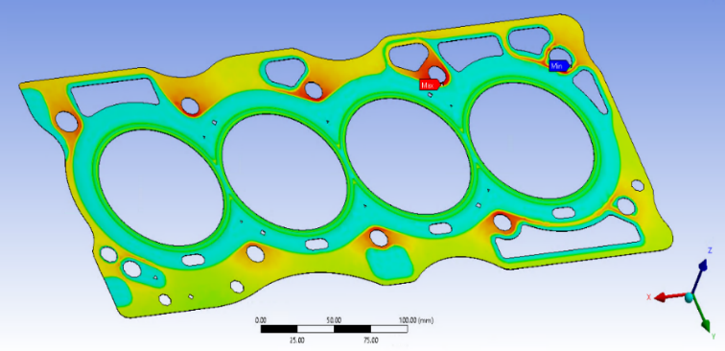
74.454 (MPa)
57.925
41.397
31.535
21.673
11.812
1.9501
-7.9114
-17.773
-27.635
Figure 11. Contact effect between the top gasket layer and the covert layersspecifications of head gaskets

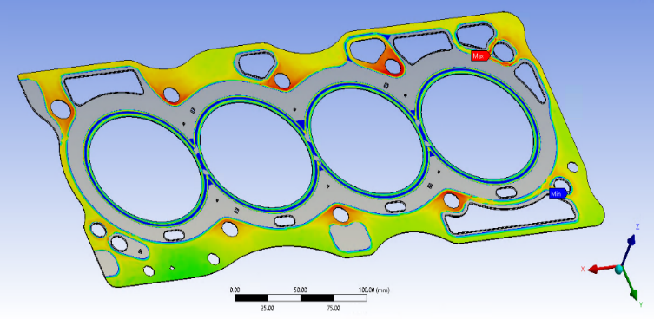
85.836 (MPa)
58.576
45.703
32.83
27.358
21.887
16.415
10.943
5.4717
0
Figure 12. Contact effect between the top gasket layer and the lower gasket layer layersspecifications of head gaskets

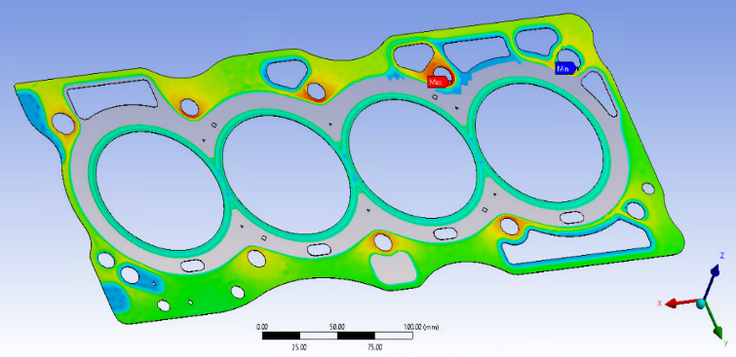
70.875 (MPa)
61.306
51.736
42.167
32.598
23.028
13.459
3.8895
-5.6799
-15.249
Figure 13. Contact effect between the lower gasket layer and the monoblock sspecifications of head gaskets

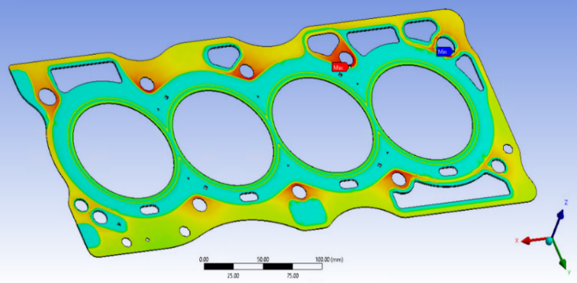
77.62 (MPa)
59.508
41.397
31.535
21.673
11.812
1.9501
-7.9114
-17.773
-27.635
Figure 14. Contact effect covert-superior gasket layer and lower gasket layer-monoblock sspecifications of head gaskets

7. Experimental corroboration

For the validation of the numerical evaluation and the model development, experimental tests of the sealing pressure are carried out under the working conditions of the bolt tightening force. One of this kind of experimental tests, is the sealing of the engine by pressure developer paper (Figure 15). For this type of evaluation, the following components are needed; Contact paper, Torque-meter, Simulating plate, Screws in good condition, Head torque specification, Head gasket (different types), Shims (if applicable). The result of the experimental evaluation shows the places where there is the highest contact pressure between the head gasket, the monoblock and the head gasket with the covert. The revealing pressure paper distribution shows contours similar to those of the numerical simulation. Furthermore, a leak test is carried out in the cylinders where a pressure of 125 to 150 Psi (1.03421 MPa) is supplied into the combustion chamber (in each cylinder), if there is any leak greater than 5% it is considered that the gasket fails, in this case it was registered 145 Psi (0.99974 MPa) in each cylinder being approved for its use.

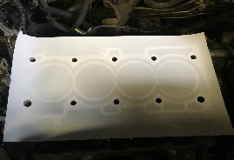
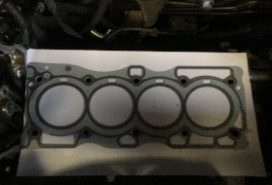
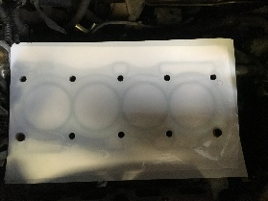
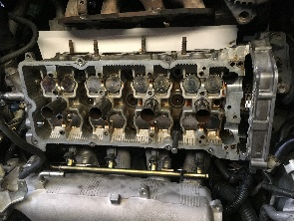
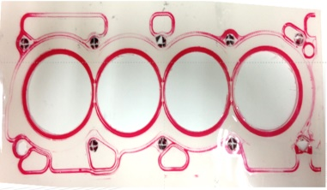
1.- Contact paper in the engine block.
2.- Place head gasket in position.
5.- Disassemble paper and result analysis.
4.- Place screws according to the sequence recommended by the supplier and carry out the tightening sequence.
3.- Applied paper in the motor side.
Figure 15. Seal test sequence with pressure developer papers

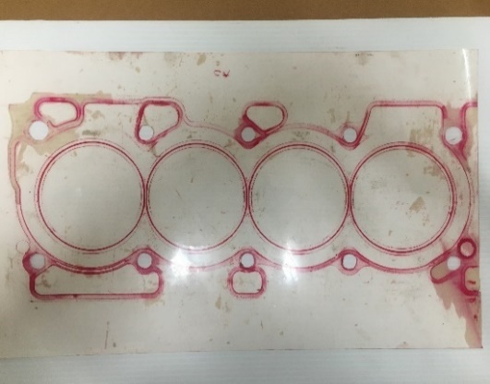
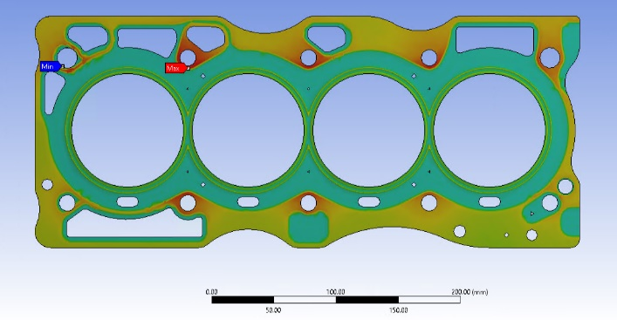
Figure 16. Comparison of contact effect between evaluations (covert to superior gasket layer)

8. Conclusions
The results presented are consequence of the effect of the acting load and the contact force in its most basic form and represents an important index on the engine head gasket sealing reliability. Figure 10 shows the von Mises stresses, which show that a ductile material begins to yield at one specific location when the stress equals the elastic limit. It would indicate, that the material could fail in this zone. When a cylinder head gasket is installed between the cylinder head and the engine block, the tightening of the head bolts slightly compresses the gasket, allowing the soft material in the gasket to conform into minor surface irregularities that exist between the platform and the block. Which allows the gasket to cold seal the system, so that no coolant fluid escapes until the engine is started. A height decrease can be observed at the ribbed areas and near the combustion chamber, as well as, at the water and oil passage areas, which indicates that, due to the pressure of the screws, when mounting them into the engine, they generate a reacting force that generates the sealing through the ribbed. Contact forces is the most basic and important index on the engine head gasket sealing reliability. In Figures 11 to 14 are shown the general distribution of the stresses on the contacts in the system. The full stresses on the ribbed in the cylinder bores are greater than half the stresses of the beads in the coolant fluid bores and lubrication bores. The maximum contact stress is 74.454 MPa. It is also observed that the cylinder area has a stress of almost 50 MPa, enough to meet the factory requirement of sealing pressure. The pressures in the cylinder zone must be more than 20 MPa according to the client's requirements.

With the development of internal combustion engines and all the studies carried out on the engines, MLS type engine seals take on great relevance in their operation, having to evolve with advances in technology. The von Mises stresses are presented, in order to know if the gasket is in risk of failure at some point of the sealing process, by observing the results data it was concluded that there is no risk of failure or damage into the component. The locking of the screws generates a reaction force that produce the seal throughout the ribbed, which it is essential to produce the sealing through the entire engine system. Correspondingly, by the numerical analysis, it can be observed that the gasket shows a very localized stress field around the cap screw, which is to be expected and can be related to the concentration of stress caused by the geometry. The numerical simulation results show that the contact stresses of the ribbed around the cylinder port are greater than 50 MPa and the contact stresses of the rib media around the refrigerant holes and lubrication holes are greater than 10 MPa, which meets the customer's design sealing pressure requirement. Correspondingly, it is concluded that the gasket sealing capacity depends mainly on the pre-stressing of the bolts, which are the main source of the maximum external load on the cylinder head. At the same time, the gasket structure at the worst seal region could be improved in the early design stages by the results obtained with the numerical analysis.

The development of this type of analysis when designing an engine gasket, will result in time savings and cost reduction, in product development, compared to the Fuji film test. Moreover, it can be established a new design process methodology, CAE and validation, which could provide improve productivity, as well as, save testing and evaluating time, costs involved in gasket design and should prove better efficiency when the product is commercializes. By producing a proper sealing between all the components of the powertrain, the engine efficiency could be increase, it can be achieved an improvement of the product performance and a reduction of emissions to the atmosphere. Finally, with the results accomplished by means of the finite element analysis and comparing with those of the experimental tests carried out, it was possible to validate that in both cases there is a coincidence.

9. Acknowledgment
The authors thank the Instituto Politécnico Nacional and the Consejo Nacional de Ciencia y Tecnología (CONACyT) for the support provided in the elaboration of this work.

10. Reference
[1] Agrawal, S. K., Internal Combustion Engines, Ed. Akal, pp 2-15, 2006.
[2] Heywood, J. B., Solutions Manual to Accompany Internal Combustion Engine Fundamentals, 2a edition, Ed. McGraw Hill, 1988.
[3] Klooster, J. W., Icons of Inventions; The Makers of the Modern World from Gutenberg to Gates, Vol. 1, Ed. Greenwood Press, pp 221, 2009.
[4] Baughman, J., Rudolf Diesel; Pioneer of the age of power, Business History Review, Vol. 39, No. 2, pp 280-282, 1965.
[5] Smil. V., Energy and Civilization; A History, Ed. MIT Press, pp 249, 2017.
[6] Sharke, P., Otto or not, here it comes; The dominant car-engine combustion process of the last century, the Otto cycle, is spawning variants and, in some instances, entirely new ignition schemes, Mechanical Engineering Magazine Select Articles, Vol. 122, No. 6, pp 62-66, 2000.
[7] Nitske, W. R. and Norman, C. M. W., Rudolf Diesel; Pioneer of the age of power, Business History Review, Vol. 39, No. 2, pp 280-282, 1965.
[8] Meyer, C. A., The impact of World War I on tractor adoption; Reflections on the industrial ideal, GMU Working Paper in Economics, No. 13-33, pp 1-19, 2013.
[9] Hoeltgebaum, T., Simoni, R. and Martins, D., Reconfigurability of engines; A kinematic approach to variable compression ratio engines, Mechanism and Machine Theory, pp 308-322, 2016.
[10] Shiga, S., Hirooka, Y., Miyashita, Y., Yagi, S., Machacon, H. T. C., Karasawa, T. and Nakamura, H., Effects of over-expansion cycle in a spark-ignition engine using late-closing of intake valve and its thermodynamic consideration of the mechanism, International Journal of Automotive Technology, Vol. 2, No. 1, pp 1-7, 2001.
[11] Bumbock, O., Schutting, E. and Eich-Seder, H., Automotive Engine Technology, Ed. H&H Automotive Engine Company, 2018.
[12] Huebner, K. H., Dewhirst, D. L., Smith, D. E. and Byrom, T. G., The Finite Element Method for Engineers, Ed. 4a edición, Ed. John Wiley & Sons, pp 570-635, 2001.
[13] Chapman, C. B. and Pinfold, M., The application of a knowledge-based engineering approach to the rapid design and analysis of an automotive structure, Advances in Engineering Software, Vol. 32, No. 12, pp 903-912, 2001.
[14] Ito, T., Sato, M., Yamaji, M. and Amasaka, K., An analysis of bottleneck technology by using experiments and CAE-example of the automotive transaxle oil seal leakage-main article, International Business & Economics Research Journal, Vol. 9, No. 12, pp 123-130, 2010.
[15] Knoll, J., Vilmann, C., Schock, H. and Stumpf, R., A dynamic analysis of rotary combustion engine seals, SAE International Congress and Exposition, pp 1-11, 1984.
[16] Madden, J. D., Mobile robots; Motor challenges and materials solutions, Science, Vol. 318, No. 5853, pp 1094-1097, 2007.
[17] Raj, K. and Grayson, M. A., Mass spectrometric studies of material evolution from magnetic liquid seals, Review of Scientific Instruments, Vol. 51, pp 1370-1373, 1980.
[18] Hu, S., Huang, W., Shi, X., Peng, Z., Liu, X. and Wang, Y., Evolution of bi-Gaussian surface parameters and sealing performance for a gas face seal under a low-speed condition, Tribology International, Vol. 120, pp 317-329, 2018.
[19] Hu, S., Huang, W., Liu, X. and Wang, Y., Stability and tracking analysis of gas face seals under low-parameter conditions considering slip flow, Journal Vibroengeering, Vol. 19, No. 3, pp 2126-2141, 2017.
[20] Hu, S., Huang, W., Liu, X. and Wang, Y., Influence analysis of secondary O-ring seals in dynamic behavior of spiral groove gas face seals, Chinese Journal of Mechanical Engineering, Vol. 29, pp 507-514, 2016.
[21] Shikary, Y. A. and Bernstein, H. M., History of automotive engine development-lesson to be learned, SAE Paper 850029, pp 1-11, 1985.
[22] Brown, D. S. and Gordon, A. L., Past, present and future of the automotive gaskets industry, SAE Technical Paper 800268, pp 1-10, 1980.
[23] Wei, Y., Yang, S., Shi, X., Li, J. and Lu, X., Finite element analysis of cylinder gasket under cylinder pressure and structural optimization of the cylinder gasket, WCX 17, SAE World Congress Experience, pp 1-22, 2017.
[24] Shanmugam, M., Setty, S. and Revoo, S., Simulation driven design and development of MLS gasket assembly, WCX World Congress Experience, pp 1-13, 2018.
[25] Robinson, H. M., Whitham, P. G. and Tronel, T., Application of advanced finite element techniques to the design and development of automotive gaskets, International Congress and Exposition, pp 1-25, 1996.
[26] Mockenhaupt, M., The 1D CAE program for cylinder head gasket design, SAE 2003 World Congress & Exhibition, pp 1-9, 2003.
[27] Kestly, M., Popielas, F., Grafl, D. and Weiss, A., Accelerated testing of multi-layer steel cylinder head gaskets, SAE 2000 World Congress, pp 1-11, 2000.
[28] Mims, A. S., Total sealing system process for automotive engine applications, SAE International Congress and Exposition, pp 1-16, 1998.
[29] Prasad, R., and Samria, N. K., Transient heat transfer analysis in an internal combustion engine piston, Computers & Structures, Vol. 34, No. 5, pp 787-793, 1990.
[30] Chen T. Y., Zwick, J., Tripathy B. and Novak, G., 3D engine analysis and MLS cylinder head gaskets design, SAE 2002 World Congress & Exhibition, pp 1-7, 2002.
[31] Popielas, F., Chen, C. and Obermaier, S., CAE approach for multi-layer-steel cylinder head gaskets; Part 1, SAE 2000 World Congress, pp 1-15, 2000.
[32] Popielas, F., Chen, C., Ramkumar, R., Rebien, H. and Waldvogel, H., CAE approach for multi-layer-steel cylinder head gaskets; Part 2, SAE 2003 World Congress, pp 1-15, 2003.
[33] Alkidas, A. C., The effects of head gaskets geometry on engine-out HC emissions from S.I. engines, Journal of Fuels and Lubricants, Vol. 108, No. 4, pp 1833-1845, 1999.
[34] Bond, S., Youngman, J. and Turland, D., A new coating for multi-layer steel exhaust gaskets, SAE 2004 World Congress & Exhibition, pp 1-9, 2004.
[35] Czernik, D. E., Gasketing the internal combustion engine, 1980 Automotive Engineering Congress and Exposition, pp 1-16, 1980.
[36] Urriolagoitia-Sosa, G., Analysis of Prior Strain History Effect on Mechanical Properties and Residual Stresses in Beams, Ph. D. Thesis, Oxford Brookes University, 2005.
[37] Ishigaki, T., Kitagawa, J. y Tanaka, A., New evaluation method of metal head gasket, SAE International Congress & Exposition, pp 1-12, 1993.
[38] Harlan, C., Novaria, P. y Robinson, M., Process and performance modelling of gasket components, Journal of Engines, Vol. 102, Sec. 3, pp 139-146, 1993.
[39] Capretta, R. y Ohigashi, H., Design methodology for automotive multi-layer steel cylinder head gaskets, International Congress & Exposition, pp 1-8, 1995.

