Aplicación del método de viga en 4 puntos
para determinar propiedades mecánicas en material anisotrópico e inducción de esfuerzos residuales para arresto de grieta

Application of the 4-point beam method
to determine mechanical properties in anisotropic material and induction of residual stresses for crack arrest

Martha Eugenia Espinosa-Hernández¹, Guillermo Urriolagoitia-Sosa², Diego Iván Islas-Jiménez³,
Beatriz Romero-Ángeles⁴, Jesus Manuel German-Carcaño⁵, Arturo Torres-Yáñez⁶,
Israel Fernando Barajas-Ambriz⁷, Israel Flores-Báez⁸, Misael Flores-Báez⁹

Grupo de Biomecánica, SEPI ESIME Zacatenco, Instituto Politécnico Nacional
Email; ¹marespher@gmail.com , ²guiurri@hotmail.com, ³islas-jimenez_17@hotmail.com,
⁴romerobeatriz97@hotmail.com, ⁵german_17jun@hotmail.com, ⁶atorresy@ipn.mx,
⁷ifba2001@hotmail.com, ⁸israelfb364@yahoo.com.mx, ⁹misaelfloresbaez@yahoo.com.mx

Resumen
La omisión en la consideración de la historia de carga previa en los componentes para el diseño mecánico impacta la vida útil. La propagación de grieta está relacionada con esfuerzos residuales e incide en la falla. En este trabajo se desarrolló un estudio analítico de una viga en cuatro puntos, para un material isotrópico y anisotrópico. Dicho estudio analiza el comportamiento elasto-plástico de la viga a flexión, con la ayuda de las ecuaciones de la Mecánica de Materiales. Se corroboran los resultados obtenidos analíticamente por medio de un modelo bidimensional de una probeta rectangular sometido a las mismas condiciones de la viga anteriormente analizada estáticamente, y se realizó el análisis de flexión mediante un programa computacional comercial del Método de Elemento Finito (MEF). Finalmente, se hizo una comparación de los resultados obtenidos de la simulación numérica contra los resultados analíticos, para de esta forma garantizar la fiabilidad de las herramientas computacionales que se utilizaron en este estudio y establecer la metodología propuesta como una prueba estandarizada de determinación de propiedades mecánicas.

Palabras clave; Mecánica de Materiales, Flexión en viga por cuatro puntos, Simulación numérica, Esfuerzos residuales.

Abstract
Failure to consider component preload history for mechanical design impacts service life. Crack propagation is related to residual stresses and promotes failure. This work developed an analytical study of a beam at four points for an isotropic and anisotropic material. Said study analyzes the elastoplastic behavior of the beam in bending, with the help of the Mechanics of Materials equations. The results obtained analytically are corroborated using a two-dimensional model of a rectangular specimen subjected to the same conditions of the beam previously analyzed statically. The bending analysis was carried out through a commercial computer program of the Finite Element Method (FEM). Finally, a comparison of the results obtained from the numerical simulation against the analytical results was made, to guarantee the reliability of the computational tools used in this study and establish the proposed methodology as a standardized test for determining mechanical properties.

Keywords; Mechanics of Materials, Bending beam at four points, Numerical simulation, Residual stress.

Introduction
One of the main challenges facing Engineering and Research in the Mechanics of Materials field is to understand the mechanisms that affect or lead materials to fail. It has been found that the omission in the consideration of the previous load history in the components at the time of the mechanical design has a significant impact on its useful life. The development of a crack is directly related to the residual stresses. Said residual stresses can influence the failure of the material since tensile stresses collaborate directly with the propagation of cracks. Knowing the magnitude and nature of these stresses are important in the design of the component, since these when combined with the conditions of the work of the part, such as fatigue, yielding, creep, corrosion, etc., can drastically reduce the useful life of the material [1-2]. In this work, the residual stress fields generated in rectangular specimens subjected to pure bending are analyzed. Two case studies are treated, with isotropic material (without previous load) and with anisotropic material (with previous loading). A comparison of analytical work and numerical analysis is carried out, in order to corroborate the reliability of the numerical analysis. The numerical simulation will be carried out through the application of the Finite Element Method (FEM). A comparison of results obtained by both methods (analytical and numerical) is recognized and the margin of error between methodologies is established.

2. The Beam Method [1, 3-6]
A very ingenious method is presented to determine simultaneously the state of stresses in tension and compression through the pure bending theory. This methodology is capable of characterizing the behavior of the material (stress-strain curve) regardless of its state of isotropy or anisotropy. The method is based on the application of a simple balance between the stress and bending moment conditions to determine the stresses (tensile-compressive) acting on the material.

Assuming that the stress-strain relationship in tension and compression of a material with a previous load history that exceeds the yield stress point is represented in Figure 1a. Likewise, the cross-section of the component is considered as shown in Figure 1b, which a bending moment (M) is applied, such that the upper and lower part of the surfaces of the beam is under the stress and strain effects (σ_{t}, ε_{t} and σ_{c}, ε_{c}) respectively (Figure 1b and Figure 1c).
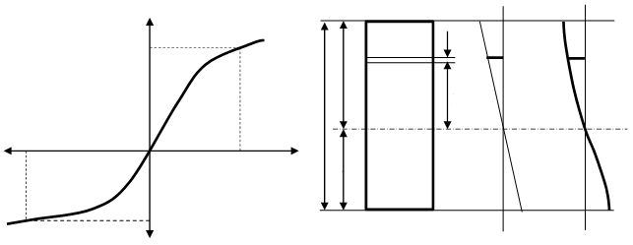
A
σ_{t}
a)
σ
B
A_{t}
ε_{c}
Width
ε_{t}
0
h
b)
A_{c}
ε
ε_{t}
0 0 0 0
h_{t}
c) d)
h_{c}
σ_{t}
ε_{c}
ε
dy
σ_{c}
y
σ
Figure 1. Free body diagram for development of the beam method. a) Stress-strain distribution.
b) Section. c) Strain. d) Stress.
B´
A´

It can be assumed that the neutral axis of the beam is at a distance h_{t} and h_{c} from the surface in tension and compression. Where the total height (h) of the beam is found in a ratio of these heights (Equation 1). The distribution of strains is assumed to be linear (assuming that the planar sections remain planar before and after bending). If the stress is due to loading at position y (Figure 1d) (Equation 2). Where f₁(y) is the function that describes how the load stress varies along the beam. This is possible if we take into account the stress-strain behavior curves (0AB and 0A´B´). It has been widely demonstrated that, under bending conditions, the neutral axis can be located by imposing an equilibrium condition where the total effect of the axial load disappears. Which, when considering the linear distribution of the unitary deformations along the beam, Equation 3 is established.

h = h_{t} + h_{c} (1)

σ₁(y) + f₁(y) (2)

A_{t} = A_{c} (3)

Where A_{c} y A_{t} represents the area under the curve and continuing with the development of the equations, it can obtain the equation to obtain the proper behavior of the material (tensile and compressive curves).

$\int_{0}^{{}_{c}}{{}_{c}}d_{c}=\int_{0}^{{}_{t}}{{}_{t}}d_{t}$ (4)

As well as, the condition of equilibrium of the internal and external moment requires that:

$M=M_{c}+M_{t}$ (5)

$M_{t}=\frac{{bh}_{t}^{2}}{ε_{t}^{2}}\int_{0}^{ε_{t}}{σ_{t}}ε_{t}{dε}_{t}$ (5.1)

$M_{c}=\frac{{bh}_{c}^{2}}{ε_{c}^{2}}\int_{0}^{ε_{c}}{σ_{c}}ε_{c}{dε}_{c}$ (5.2)

Applying a mathematical solution to develop the equation can be obtaining the final equation (to analyze the entire mathematical procedure see references [1 and 6]):

$σ_{αt}=\frac{\overline{M_{k}}-\overline{M_{k-1}}}{{\overline{ε}}_{k}{∆ε}_{αk}}$ (6)

3. Analytic development of cases of study
Two cases of the study were developed; considering the isotropic and the anisotropic condition in the material.

3.1 Isotropic material bending case
To determine the maximum moment that produces elastoplastic stress of 800 N/mm² and strain of 0.011 is applied, where the moment is solved with respect to the strains of the system and applying the 4-point bending equation. As the material behaves bilinear, it can be assumed that the component from its neutral axis to the surface (lower or upper) is divided into two zones; one linear-elastic and the other elastoplastic [1 and 7]. Once the value of the moment to reach the yield stress of the material has been calculated, it is possible to obtain the height from the neutral axis in the beam that is in elastic stress effects. This is done by applying a linear relationship of the strains that are produced by loading the system. Subsequently, the distribution of the elastic and plastic zones is determined. Next, by superposition, the stress, strain, moment distribution, and residual stress are calculated.
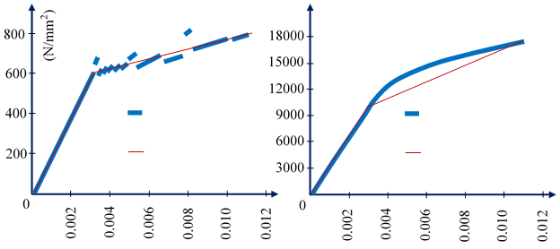
Proposed
Calculated
a)
σ
Proposed
Calculated
b)
ε
ε
M
Figure 2. Application of the 4-point beam method to determine maximum load moment. a) Stress-strain interaction. b) Moment-strain interaction.

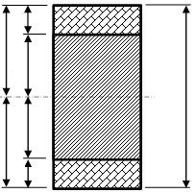
Z_{t}; Tensile total zone.
Z_{c}; Compressive total zone.
C_{pt}; Tensile plastic height.
C_{pc}; Compressive plastic height.
C_{et}; Tensile elastic height.
Cec; Compressive elastic height.
10 mm
Z_{t}

Z_{c}

C_{pt}

C_{pc}

C_{et}

C_{ec}

Figure 3. Distribution of effects in the cross section of the beam

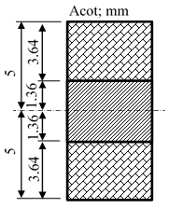
Figure 4. Distribution results on the elastic and plastic zones in an isotropic material

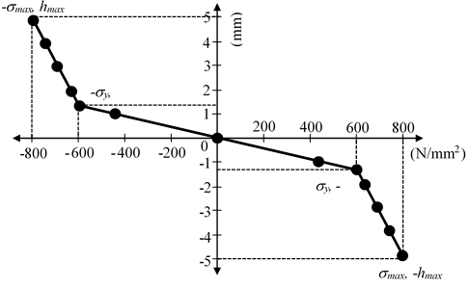
Figure 5. Analytical load distribution for stress-strain state in isotropic material

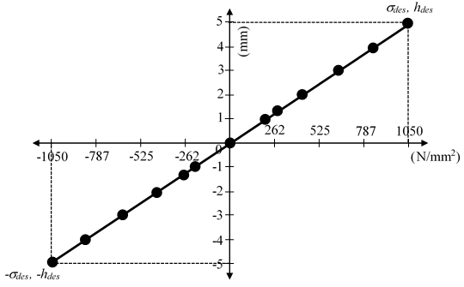
Figure 6. Analytical unload distribution for stress-strain state in isotropic material

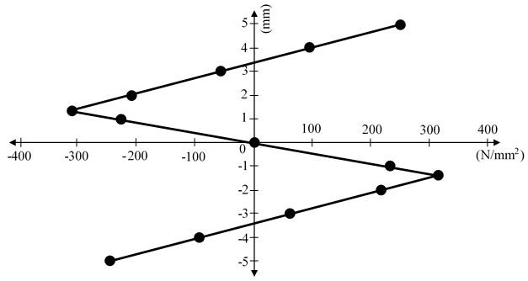
Figure 7. Analytical residual stress distribution for stress-strain state in isotropic material

3.2 Anisotropic material bending case
In this section, the same arrangement (which we have worked previously) is considered (initial behavior of the material is treated an isotropic). However, in this section we will work with an anisotropic material behavior. As well as, application of the kinematic hardening rule. Anisotropic behavior can be developed in the component through the application of a homogeneous load in axial tension and with this cause strain hardening and Bauschinger effect. The component undergoes a previous homogeneous load of 700 N/mm². Where the first phase behavior (Figure 8; blue line) is the original isotropic behavior of the material.
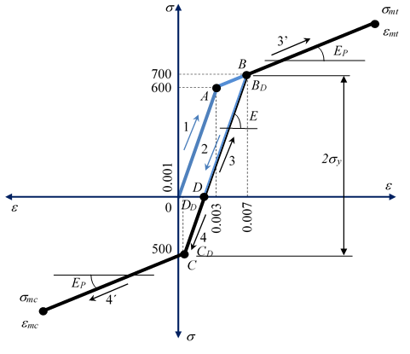
Figure 8. Produced anisotropic behavior of the material for the study case

Which, due to the application of the homogeneous axial load, enters a second phase of the procedure, which is an anisotropic behavior (black line). This second phase is the behavior in which the structural system must comply with a non-homogeneous load (bending) applied.

Once the stress-strain behavior, it is possible to develop all kinds of calculations for the bending case and the residual stress induction. This is done by applying a linear relationship of the strains that are produced by loading the system. Subsequently, the distribution of the elastic and plastic zones is determined. Next, by superposition, the stress, strain, moment distribution, and residual stress are calculated.
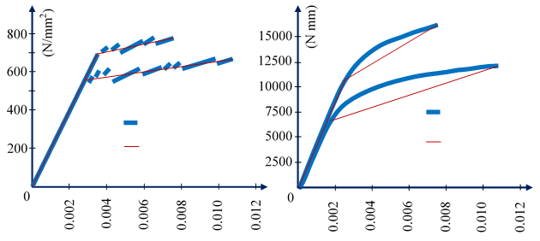
Proposed
Calculated
a)
σ
Proposed
Calculated
b)
ε
ε
M
Figure 9. Application of the 4-point beam method to determine maximum load moment in material with anisotropic behavior. a) Stress-strain interaction. b) Moment-strain interaction.

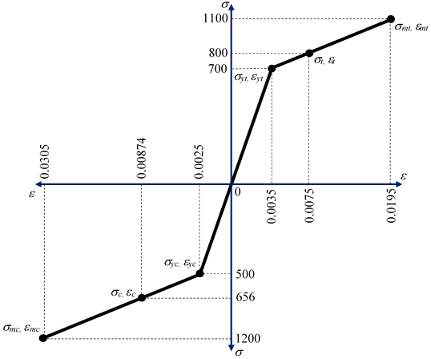
Figure 10. Modification of the origin to develop anisotropic behavior in the material

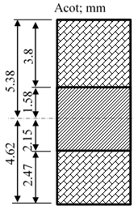
Figure 11. Distribution results on the elastic and plastic zones in an anisotropic material

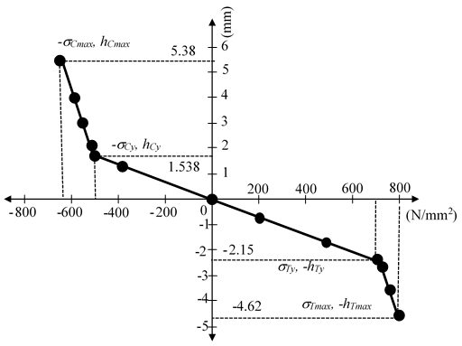
Figure 12. Analytical load distribution for stress-strain state in anisotropic material

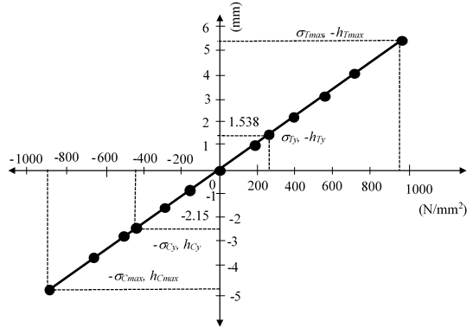
Figure 13. Analytical unload distribution for stress-strain state in anisotropic material

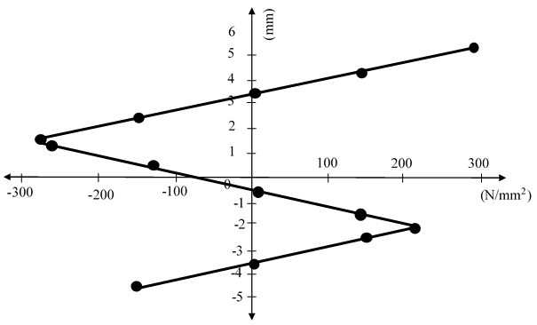
Figure 14. Analytical residual stress distribution for stress-strain state in anisotropic material

4. Numerical development of cases of study [10-11]
For the two cases of study the development of the numerical analysis its applied by the finite element method [8]. It is stipulated that the numerical simulation is developed structurally. An analysis will be carried out in 2D and applying plane stress theory. As well, high order quadrilateral solid elements are applied (Solid brick 20 nodes). Three degrees of freedom are activated (displacements in the x and y axes, rotation in the xy plane). The bilinear mechanical properties stipulated above are respected. Likewise, a kinematic hardening is proposed for these study cases. The model is discretized in a controlled manner and produces quadrilateral elements. In addition, the vertical lines are divided into 10 mm and the horizontal lines into 100 mm, with which there will be elements of 1 mm². The bottom left node is constrained on both offsets and the bottom right node is constrained on the y-axis to offset only. It is important to note that rotation in the xy plane is active.
P P
UX = 0
UY = 0
UY = 0
Figure 15. Discretized model with application of external agents

4.1. Numerical isotropic material bending case
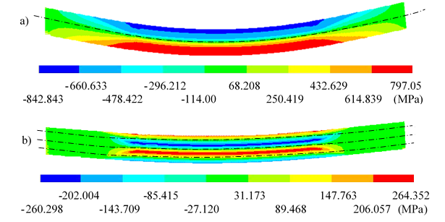
As the material behaves bilinear, it can be assumed that the component from its neutral axis to the surface (lower or upper) is divided into two zones; one linear-elastic and the other elastoplastic [1 and 7]. Numerical simulation is carried out and loading stress and residual stress are obtained.
Figure 16. Numerical nominal stress on the x axis. a) Loading. b) Unloading.
Neutral axis
Neutral axis

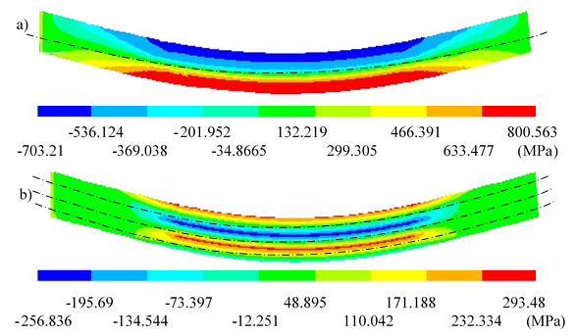
Neutral axis
Neutral axis
Figure 19. Numerical nominal stress on the x axis. a) Loading. b) Unloading.

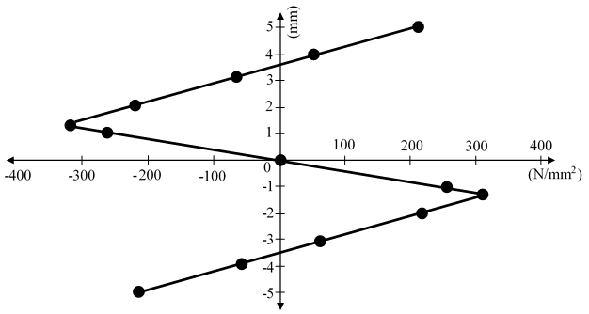
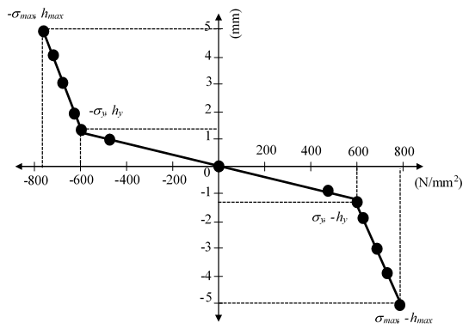
Figure 17. Nominal stress on the x axis.
a) Loading stress. b) Residual stress (Unloading).
a)
b)

4.2. Numerical anisotropic material bending case
The numerical study is developed by taking into consideration the analytical considerations previously stated for an anisotropic material [1 and 7]. Numerical simulation is carried out and loading stress and residual stress are obtained. Nevertheless, to develop the numerical evaluation, first has to produce anisotropy into the material by homogenously pulling the material and unloaded (Figure 8). Then the bending process has to be developed.

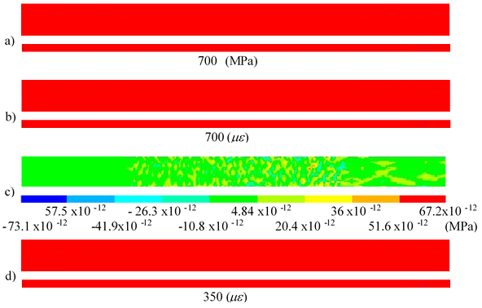
Figure 18. Effects due to the application of homogeneous loads. a) Nominal stresses on the x axis under load. b) Unitary deformations in x-axis under load. c) Nominal stress on the x axis in unloading. d) Unitary strain on the x axis in unloading.

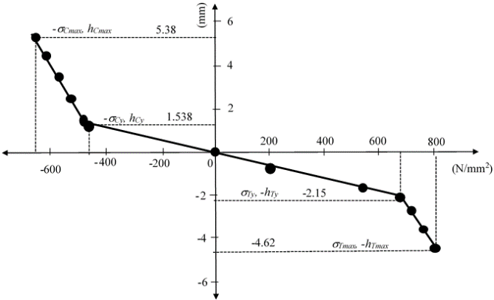
Figure 20. Loading nominal stress on the x axis

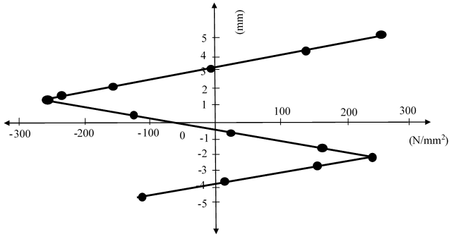
Figure 21. Residual stress on the x axis

5. Conclusions
From the results obtained through analytical work and numerical analysis, a comparison is produced. So, it is possible to determine the efficiency of the applied methods.

Table 1. Comparative table with results obtained
High (mm) | Analytic | Numeric | Analytic | Numeric
 | Stress x (N/mm²) | Stress x (N/mm²) | Residual stress (N/mm²) | Residual  stress (N/mm²)
5.38 | -656 | -658.70 | 295.03 | 252.11
4.38 | -612.31 | -624.69 | 148.52 | 136.11
3.38 | -568.65 | -581.37 | 1.97 | -10.77
2.38 | -524.99 | -537.79 | -144.575 | -157.39
1.538 | -500 | -459.585 | -279.738 | -239.33
1.38 | -448.634 | -444.91 | -258.434 | -254.71
0.38 | -123.53 | -123.60 | -123.53 | -123.60
-0.62 | 201.86 | 209.89 | 11.66 | 19.686
-1.62 | 526.76 | 543.37 | 146.345 | 162.97
-2.15 | 700 | 700 | 218.775 | 238.91
-2.62 | 725.072 | 722.86 | 154.452 | 152.26
-3.62 | 762.53 | 765.81 | 1.7 | 5.009
-4.62 | 800 | 799.56 | -151.03 | -111.25
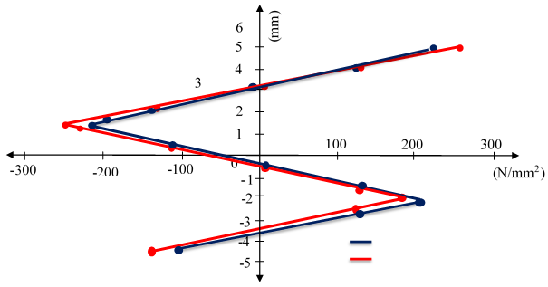
Analytic
Numeric
Figure 22. Comparison of the numerical distribution for residual stress state against analytical distribution for residual stress state in anisotropic material

In this work, an analytical study of a beam at four points was developed, in an isotropic material and later an anisotropic material. This study analyzes the plastic behavior of the beam in bending, with the help of the Mechanics of Materials equations. The results obtained were tabulated and graphed to observe the mechanical behavior that the element presents. Also, the 4-point bending beam method is a powerful tool to determine stress-strain behavior and estimate the degree of anisotropy in the components. The anisotropy condition is a consequence of previous homogeneous loading, which affect drastically the resistance of the material and modified the residual stress distribution. The residual stress distribution could be applied to endure the mechanical resistance, but if the condition of the material (isotropic or anisotropic) is misunderstood the mechanical resistance could be diminished. Additionally, the 4-point bending method could be a powerful tool to be used in the industry to identify the material behavior under the loading process and facilitate the proper use of material to develop components.

In order to corroborate the results obtained analytically, a two-dimensional model was produced of a rectangular specimen subjected to the same conditions as the beam previously analyzed statically, and the bending analysis was carried out using a finite element computational program. Finally, a comparison was performed of the results obtained from the numerical simulation against the analytical results in order to guarantee the reliability of the computational tools used in this study. The residual distrubition could also determine the manner and region where the failure starts. Additionally, the residual stress field can be controlled by the manufacturing process and increment the resistance of the material.

6. Acknowledgment
The authors thank the Instituto Politécnico Nacional and the Consejo Nacional de Ciencia y Tecnología (CONACyT) for the support provided in the elaboration of this work.

7. Reference
[1] Urriolagoitia-Sosa, G., Analysis of Prior Strain History Effect on Mechanical Properties and Residual Stresses in Beams, Ph.D. Thesis, Oxford Brookes University, pp 3-15, 2005.
[2] Urriolagoitia-Sosa, G., Urriolagoitia-Calderón, G., Romero-Ángeles, B., Torres-Franco, D., Hernández-Gómez, L. H., Molina-Ballinas, A., Torres-San Miguel, C. R. and Campos-López, J. P., Using fracture mechanics for determining residual stress fields in diverse geometries, Ingeniería e Investigación, Vol. 32, No. 3, pp 19-26, 2012.
[3] Urriolagoitia-Sosa, G., Durodola, J. F. and Fellows, N. A., Determination of tensile and compressive stress-strain curves from bend tests, Applied Mechanics and Materials, Vols. 1-2, pp 133-138, 2004.
[4] Laws, V., Derivation of the tensile stress-strain curve from bending data, Journal of Materials Science, Vol. 16, No. 5, pp 1299-1304, 1981.
[5] Mayville, R. A. and Finnie, I., Uniaxial stress-strain curves from a bending test, Experimental Mechanics, Vol. 22, No. 6, pp 197-201, 1982.
[6] Urriolagoitia-Sosa, G., Durodola, J. F. and Fellows, N. A., Determination of residual stress in beams under Bauschinger effect using surface strain measurements, Strain, Vol. 39, No. 4, pp 177-185, 2003.
[7] Hibbeler, C., Material Mechanics, Ed. Pearson Prentice Hall, pp 263-266, 2006.
[8] ANSYS, Mechanical APDL Basic Analysis Guide Reléase 16, ANSYS Inc Company, 2013.
[9] Urriolagoitia-Sosa, G., Durodola, J. F. y Fellows, N. A., Effect of strain hardening on residual stress distribution in beams determined using the crack compliance method, Journal of Strain Analysis for Engineering Design, Vol. 42, No. 2, pp 115-121, 2007.
[10] Urriolagoitia-Sosa, G., Durodola, J. F., Lopez-Castro, A. and Fellows, N. A., A method for the simultaneous derivation of tensile and compressive behaviour of materials under Bauschinger effect using bend tests, Proceedings of the Institution of Mechanical Engineers, Part C: Journal of Mechanical Engineering Science, Vol. 220, No. 10, pp 1509-1518, 2006.

