Desarrollo de un modelo numérico para evaluación
sobre los efectos de porosidad en el fémur proximal

Development of a numerical model to evaluate
the effects of porosity in the proximal femur

Martín Eduardo Villanueva-Piñón¹, Guillermo Urriolagoitia-Sosa², Beatriz Romero-Ángeles³,
Daniel Maya-Anaya⁴, Omar Isaac Hernández-Patiño⁵, Salvador Cruz-López6,
Arturo Sánchez-Cervantes7, Alfonso Trejo-Enríquez⁸, Martn Ivan Correa-Corona⁹

Grupo de Biomecánica, SEPI ESIME Zacatenco, Instituto Politécnico Nacional
Email; 1m.eduardo2592@gmail.com, 2guiurri@hotmail.com, 3romerobeatriz97@hotmail.com,
4danmaa02@gmail.com,5ing.omarhp@gmail.com, 6salvadorcruzlopezim@gmail.com,
7artursc4@hotmail.com, 8ponchoponchotrejo@outlook.com, 9ingenieria.ivan.95@gmail.com

Resumen
En el desarrollo de modelos numéricos que son aplicados para evaluar los huesos humanos, como un componente estructural hasta el día de hoy, se han superado las condiciones de linealidad, isotropía y continuidad, que dictan en contextos la Mecánica de Materiales para simplificar los casos de estudio y obtener soluciones. Sin embargo, existe una condición que aún se debe de superar, la homogeneidad del componente. En el presente trabajo se desarrolla un modelo numérico del fémur proximal introduciendo porosidad existente en el sistema. Se realizan la evaluación mediante el Método del Elemento Finito para determinar el efecto de la porosidad en el modelo numérico. El biomodelo es generado a partir de un estudio tomográfico y está constituido por dos tipos de tejido óseo; hueso cortical y el hueso trabecular. Los análisis realizados simulan la carga que soporta un fémur cuando una persona se encuentra en bipedestación. Estas cargas provocan diversos efectos internos. Sin embargo, el comportamiento mecánico del hueso cambia debido al nivel de porosidad. Para observar las diferencias se presentan los esfuerzos y deformaciones unitarios de un caso sin porosidad y otro caso con porosidad.

Palabras clave; Fémur proximal, Simulación numérica, Porosidad, Método de Elemento Finito.

Abstract
In the development of numerical models that are applied to evaluate human bones, as a structural component to this day, the conditions of linearity, isotropy, and continuity have been overcome, which dictate in Mechanics of Materials contexts to simplify the cases of study and get solutions. However, a condition that must still be overcome is the homogeneity of the component. In the present work, a numerical model of the proximal femur is developed by introducing existing porosity in the system. The evaluation is carried out using the Finite Element Method to determine the effect of porosity in the numerical model. The biomodel is generated from a tomographic study and is made up of two types of bone tissue; cortical bone and trabecular bone. The analyses were carried out to simulate the load a femur supports when a person is standing. These charges cause various internal effects. However, the mechanical behavior of the bone changes due to the level of porosity. The stress and strain of a case without porosity and another with porosity are presented to observe the differences.

Keywords; Proximal femur, Numerical simulation, Porosity, Finite Element Method.

Introduction
The human body has been the object of study for a long time, although due to its difficulty in analyzing internal structures and physiological processes, non-invasive techniques have had to be resorted to achieve this goal. Bones are a popular object of study due to their mechanical properties and because they are the weight-bearing structures of the human body. Carrying out simulations about the behavior of bone structures allows us to predict the process that will take place in the bone when faced with external agents. Experimental testing could be expensive and complicated. The finite Element Method (FEM) is a mathematical tool that has gained importance in recent years and allows to perform this type of task to evaluate the behavior of anatomical structures [1]. The accuracy of the results of finite element analyses depends on knowing the mechanical properties of the bone. For this reason, develop multiple experiments on human bone specimens to learn more about their behavior [2]. However, the considerations to take into account are several since the structure of the bone varies for several reasons; age, gender, race, and pathologies. In addition, each bone behaves differently, so you can only have approximate values to the real ones, which can cause inaccuracy in the results. Even the bone changes its structure when it is in a different environment than the human body [2]. One of the most important bones in the human body is the femur, considered the largest and longest bone, which is part of the hip joint and can withstand up to 30 times the weight of an adult. For this reason, studying the behavior of this bone structure is of great importance [3]. In addition, in pathologies such as osteoporosis, where the bone becomes more porous, the loads it supports are lower, which can lead to fractures in certain areas.

A wide variety of conditions, such as osteoporosis, cause increased fracture risks in biological systems and can affect patient mobility. Carrying out studies of this type of disease (osteoporosis) through techniques such as the Finite Element Method (FEM) helps to observe the probable behavior that biological systems will suffer under various factors or external agents. The porosity that exists in bone structures is empty spaces where there is no bone tissue. This characteristic is considered inversely proportional to many mechanical properties. Therefore, an increase in the porosity will produce more reduction in stiffness and resistance. In addition, the porosity found in bones is not the same throughout the entire structure. There are areas where the number of pores is superior to others [4]. Thanks to various studies, it has been determined that BMD is related to bone stiffness, which means that a change in this value will influence the values ​​of Young's modulus and bone density. Therefore, if the BMD decreases, these values ​​mentioned above will also decrease [5]. In this way, the development of osteopenia or osteoporosis will cause a decrease in the value ​​of the mechanical properties of bone structures [6].

For the development of this research work, a computational numerical model of the upper part of the femur is carried out. Since the object of study is the femoral head and the adjacent areas. Because it is in this area where fractures occur. Three study cases are developed. Initially, a study case where the model is considered without porosity. The second study case was performed by taking into consideration a model with mechanical properties of bone with porosity. Finally, a model was performed where the pores are physically incorporated into the model. A result comparison is presented between the three proposed models and a discussion of the effects that are presented.

2. Development of the computational bone biomodel
There are multiple ways to develop a computational bone model. This is because for each step in the process different programs allow performing certain tasks. The methodology used in this work is as follows [7]:

1. Obtaining the tomographic images of the anatomical structure to be analyzed, in DICOM format.
2. Processing of the tomographic images in a computer program to develop the modeling.
3. Correction of model errors and export in a file with *.STL extension.
4. Import the model into a CAD program for solidification.
5. Importation of the computational model in a Finite Element program to carry out the analysis.
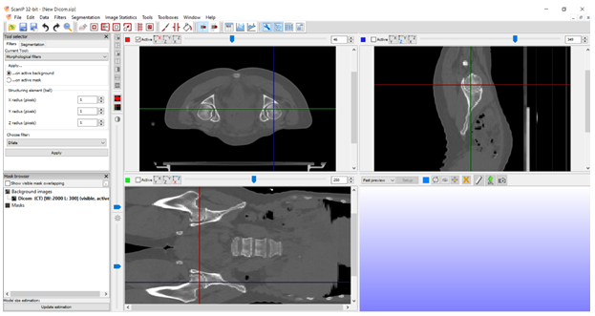
Figure 1. Sagittal, coronal, and transversal views in the study of tomographic images.

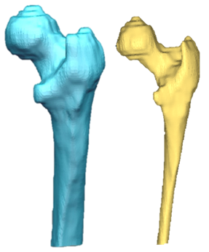
a) b)
Figure 2. Computational model of the bone femur after smoothing and the generation of surfaces.
a) Cortical bone. b) Trabecular bone.

3. Numerical analysis of the femur bone model
The numerical analysis of the model of the proximal femur bone is mostly carried out in the computational program of the Finite Element Method LS-PrePost, which is a Preprocessing and Postprocessing program. As well, the solution is provided by the Ansys LS-DYNA program. A numerical evaluation is carried out under Isotropic, Elastic, Continuous, and Homogeneous conditions. As well as, is a static evaluation, under maximum load conditions. In the scientific community, it is very well established that the implementation of numerical simulations through the Finite Element Method is developed through three processors (preprocessor, processor, and postprocessor). It was necessary to establish that the type of analysis to be carried out will be structural and the model will be developed in a 3D manner. Additionally, the model has been generated with two materials (Cortical and Trabecular bones).

3.1. Model discretization
For the three case studies, the same model is used, which is discretized in a semi-controlled manner. High-order solid elements were applied.
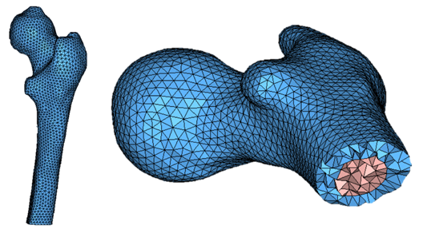
Figure 3. Discretized cortical bone and trabecular bone of the proximal femur (tetrahedral elements)
Cortical bone
Trabecular bone

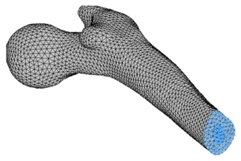
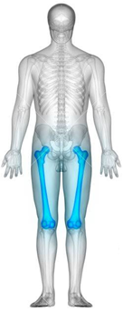
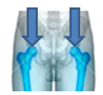
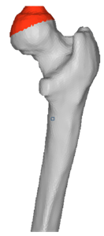
U_{x} = 0
U_{y} = 0
U_{z} = 0
Rot_{x} = 0
Rot_{y} = 0
Rot_{z} = 0
a)
b)
P = 96 kg
P/2 = 48 kg
P = 470 N
Figure 4. Application of external agents.
a) Boundary conditions. b) Load.

3.2. Mechanical properties
Bone is a material with different properties depending on its direction, which leads to simulations with specific considerations [8]. The material of the bone without porosity consideration is presented in Table 1. The mechanical properties of the model considering porosity are shown in Table 2 [9].

Table 1. Bone mechanical properties
Young´s modulus (MPa) | Shear´s modulus (MPa) | Poisson ratio
Trabecular bone
E₁ = 1 352 | G₁₂ = 399 | υ₁₂ = 0.3
E₂ = 822 | G₂₃ = 370 | υ ₂₃ = 0.3
E₃ = 822 | G₁₃ = 399 | υ ₁₃ = 0.3
Cortical bone
E₁ = 16 000 | G₁₂ = 3 300 | υ₁₂ = 0.3
E₂ = 6 300 | G₂₃ = 3 600 | υ ₂₃ = 0.45
E₃ = 6 300 | G₁₃ = 3 300 | υ ₁₃ = 0.3

Table 2. Bone mechanical properties with osteoporosis
Young´s modulus (MPa) | Shear´s modulus (MPa) | Poisson ratio
Trabecular bone
E₁ = 239 | G₁₂ = 138 | υ₁₂ = 0.25
E₂ = 201 | G₂₃ = 141 | υ₂₃ = 0.40
E₃ = 201 | G₁₃ = 138 | υ₁₃ = 0.25
Cortical bone
E₁ = 7 972 | G₁₂ = 1 916 | υ₁₂ = 0.25
E₂ = 3 066 | G₂₃ = 2 146 | υ₂₃ = 0.40
E₃ = 3 066 | G₁₃ = 1 916 | υ₁₃ = 0.25

3.3. Application of external agents
After assigning the model to both structures (materials), the boundary conditions of the computational model of the femur are declared. To perform this task, the first step is to create a set of nodes at the base of the entire femur, and then assign a displacement and rotation constraint in all axes (Figure 4). Movement (displacement and rotation) in all directions is restricted in this zone. However, the sequence of application of the external agent and the boundary conditions is indistinct and the order in its application will not harm the development and accuracy of the analysis. The application of the external agent will consist of applying a uniformly distributed load on a small section of the femoral head, which will simulate a normal load that the femur of a person in a standing position. An individual weighing 96 kg was selected and the weight is divided between the two legs on which the individual will be supported. Just as the conversion to Newtons is performed. The external agent is applied to the femoral head (on the longitudinal axis) and the applied axial load is approximately 470 N. Although simulations with different amounts of load were carried out in various analyzes that have been carried out [10].

4. Solution and results for study cases
Three study cases are presented, using the same biomodel. The three study cases apply the same boundary conditions, and the same load was applied promptly.

4.1. First study case
The objective of this first analysis is to validate that the biomodel in its development was correct and functional. After proceeding to solve the analysis, several results are displayed to corroborate the reliability of the analysis. Results for cortical and trabecular bones are shown separately.
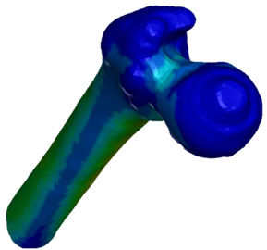
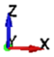
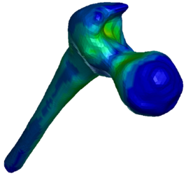
Figure 5. First case, Von Mises stress
12.7 (MPa)
11.4
10.2
8.9
7.5
6.3
5.1
3.8
2.6
1.3
0.0
Trabecular bone
0.86 (MPa)
0.78
0.69
0.61
0.53
0.44
0.36
0.27
0.19
0.10
0.02
Cortical bone

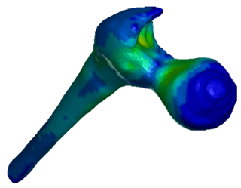
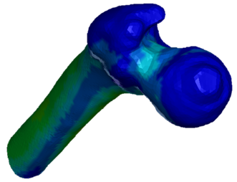
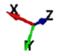
Figure 6. First case, general shear stress
6.42 (MPa)
5.78
5.14
4.50
3.86
3.22
2.58
1.94
1.30
0.66
0.02
Trabecular bone
0.46 (MPa)
0.42
0.37
0.33
0.28
0.24
0.19
0.15
0.10
0.06
0.01
Cortical bone

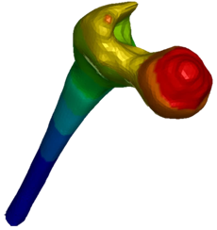
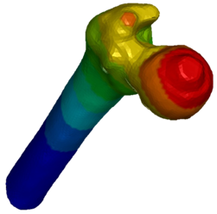
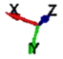
Figure 7. First case, general displacement
0.85 mm
0.77
0.68
0.60
0.51
0.43
0.34
0.26
0.17
0.09
0.00
0.82 (mm)
0.74
0.66
0.58
0.49
0.41
0.33
0.25
0.16
0.08
0.00
Trabecular bone
Cortical bone

4.2. Second study case
In the second case presented in this research work, the numerical analysis is developed using the same numerical model as the previous study. Likewise, the boundary conditions and load value shown in Figure 4 are reapplied. However, the evaluation is carried out by applying the mechanical properties shown in Table 2. Once again, after proceeding to solve the analysis, several results are displayed to corroborate the reliability of the analysis. Results for cortical and trabecular bones are shown separately. The only significant change between the first study case and the second study case is the mechanical properties. The mechanical properties considered in the second study case are taken into consideration from patient bone with a medium level of osteoporosis. Osteoporosis tends to induce and/or enlarge the porosity proper of the bone.
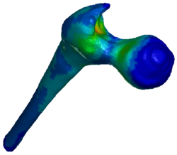
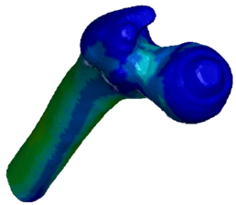
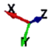
Figure 8. Second case, Von Mises stress
12.5 (MPa)
11.3
10.05
8.80
7.54
6.29
5.03
3.78
2.52
1.27
0.01
Trabecular bone
0.55 (MPa)
0.49
0.44
0.39
0.33
0.28
0.23
0.17
0.12
0.07
0.01
Cortical bone

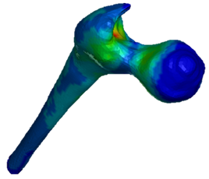
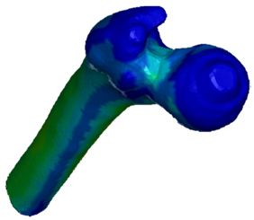
Figure 9. Second case, general shear stress
6.39 (MPa)
5.70
5.07
4.44
3.80
3.17
2.54
1.91
1.27
0.64
0.01
Trabecular bone
0.30 (MPa)
0.27
0.24
0.21
0.18
0.15
0.12
0.09
0.07
0.04
0.01
Cortical bone

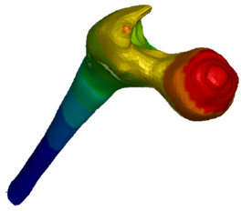
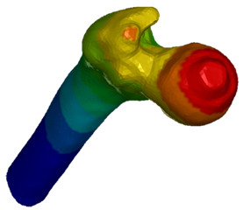
Figure 10. Second case, general displacement
1.64 mm
1.48
1.31
1.15
0.98
0.82
0.66
0.49
0.33
0.16
0.00
Trabecular bone
0.98 (mm)
0.88
0.79
0.69
0.59
0.49
0.39
0.29
0.20
0.10
0.00
Cortical bone

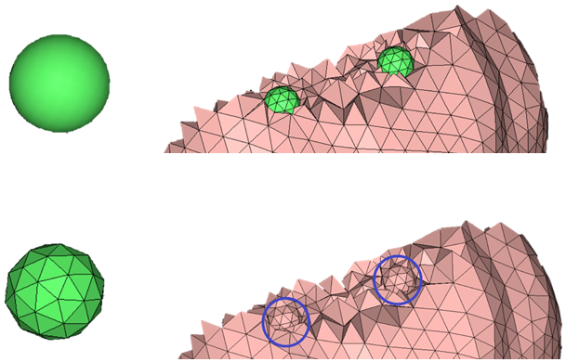
Hollow sphere
Discretized
hollow sphere
a)
b)
Figure 12. Introduction of the pore into the model.
a) Discretization of the spherical surface (green) showing the location of two pores (only for visualization). b) Portion of the final trabecular bone model with two visible pores (blue)

4.3. Third study case
To study the effect of porosity, the geometry of the cortical and trabecular bone model used in the previous analysis was modified, adding vacancies, re-analyzed, and compared results. The process used in this research work to introduce porosity in the model can be done in two ways; adding pores in the geometry of the bone (in this case, in the model in CAD format) or doing it directly in the discretization. It was decided to add empty spaces directly in the discretization of the computational model of the femur because it is more practical to start from a model already meshed correctly and without any error than to begin the process of modifying a CAD file again. To carry out this process the Hypermesh program was used since it has more tools to carry out the discretization process. Likewise, the same discretized models of cortical and trabecular bone used in the previous analysis were applied.
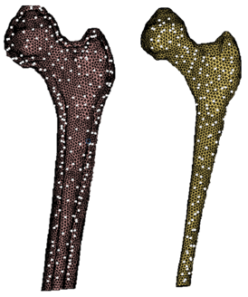
Figure 11. Hollow spheres
generated within both biomodels
(cross section for viewing)
Cortical bone
Trabecular bone

To introduce the pore, hollow spheres were generated within the cortical bone and trabecular bone. The spheres have a diameter of 1.5 mm radius, and it was configured in such a way that they were distributed equally through the models and that they had the same distance between them. The location of the spheres within the discretized shell of the bone models is done manually. This means that the locations were selected based on some nodes located on the surface of the models and from there they are moved inside the structures. Thanks to the measurement tools, it is ensured that the distance between these spherical surfaces is equal so that they are distributed correctly.

Although it is possible to develop smaller pores, it was decided to select spheres with a diameter of 1.5 mm, because making smaller pores would imply making a discretization with smaller elements on the surface of the pore. Which, in turn, would significantly increase the number of elements and nodes. Therefore, the computational resource would not be sufficient to solve the analysis or the solution time would be extremely long in solution time.

In the third study case presented in this research work, the numerical analysis is developed using the same numerical model as the previous study. Likewise, the boundary conditions and load value shown in Figure 4 are reapplied. The evaluation is carried out by applying the mechanical properties shown in Table 1. Once again, after proceeding to solve the analysis, several results are displayed to corroborate the reliability of the analysis. Results for cortical and trabecular bones are shown separately. The only significant change between the previous two study cases and the third study case is the introduction of porous into the bone model system. By applying this kind of technique it is possible to modify the pore as we like and evaluate this disses. Also, it is possible to analyze the structural damage produced in the bone and propose the kind of exercises that the patient can perform.
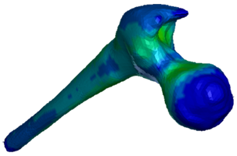
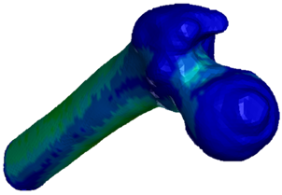
Figure 13. Third case, Von Mises stress
19.54 (MPa)
17.59
15.64
13.68
11.73
9.77
7.82
5.86
3.91
1.95
0.00
Trabecular bone
1.08 (MPa)
0.98
0.87
0.76
0.65
0.54
0.43
0.33
0.22
0.11
0.00
Cortical bone

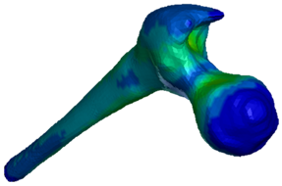
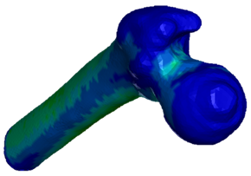
Figure 14. Third case, general shear stress
10.05 (MPa)
9.04
8.04
7.03
6.03
5.02
4.02
3.01
2.01
1.00
0.00
Trabecular bone
0.58 (MPa)
0.52
0.46
0.40
0.35
0.29
0.23
0.17
0.12
0.06
0.00
Cortical bone

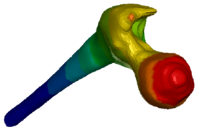
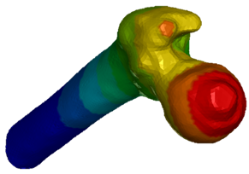
Figure 15. Third case, general displacement
1.02 (mm)
0.92
0.81
0.71
0.61
0.51
0.41
0.31
0.20
0.10
0.00
Trabecular bone
0.98 (mm)
0.88
0.79
0.69
0.59
0.49
0.39
0.29
0.20
0.10
0.00
Cortical bone

5. Conclusions
In the present research work, several computational biomoddeveloped loodelop for their subsequent analysis. First, a methodology was described to build the proximal biomodel of the human femur, from tomographic images, which represented an advantage because the dimensions of these biomodels correspond to the real ones.

Three different analyzes were performed applying the biomodel developed by tomography. The first analysis consisted of the simulation of a healthy proximal femur supporting a load of a person (with an average weight) when standing. In the second case study, the same computational biomodel was used, although with the mechanical properties of a bone with osteoporosis. For the last analysis, a geometry modification was done to add pores in it and simulate what happens in a bone. For this third analysis, the mechanical properties of the biomodel from the first analysis were applied. It is important to mention, that although in a general manner there is the presence of a single bone structure (femur), it is built up of two different types of bone tissue (cortical bone and trabecular bone). In the three analyzes carried out in this research work, the complete computational biomodel of the proximal femur was subdivided into two parts to represent both types of bone, each with its characteristics and mechanical properties.

The results comparison between the first case of study (healthy bone) against the other two (representing a bone with porosity) shows that the stress and displacement values are lower. This is because, as the healthy bone has greater rigidity, it will move less than one with less rigidity.

Comparing results between the second and third analyses, it is important to highlight that (in most cases), these biomodels begin to exhibit similar behavior. In both, the general displacement increases (being more noticeable in the biomodel with porosity) since the stiffness is lower and stress values ​​increases concerning the first analysis. The stress distribution in both study cases is similar, being the critical areas mainly at the neck of the femur and also in the body (intermediate part). However, regarding some stress tests on osteoporotic bone material mentioned in the literature, it has been shown that the yield point in this type of material decreased, so it is important to conclude that a bone with osteoporosis will first reach fracture with less stress than healthy bone. Discrepancies between both biomodels (simulating porosity) may be due to; the pores added in the third computational biomodel being larger than the actual approximate measurement of the pores in an osteoporotic bone or due to computational resource issues (these vacancies could not be modeled smaller). Also, the porosity that was added in the third biomodel was distributed in the same way throughout the entire three-dimensional model (in reality each bone exhibits porosity distributed differently, concentrating in different areas), which leads to a slightly different mechanical behavior. Even among the same types of bone from different patients, the porosity is not the same, although for practical purposes we proceeded to add evenly distributed porosity throughout the biomodel. While the increase in the stress values was not that great, it is important to remember that only the simulation of the load supported by the femur of a person in a standing position is being carried out. However, many of the fractures of people with osteoporosis (and even without this condition) are due to the different types of falls. So, in dynamic analysis, the increase in stress is likely greater.

This kind of model construction permits the modification of the component homogeneity and the addition of microstructural faults. Which allows the development of analyzes closer to reality and treat biological systems in a better way. As well as, allows the development of better prostheses and the implementation of optimal methodologies for the recovery of patients.

6. Acknowledgment
The authors thank the Instituto Politécnico Nacional and the Consejo Nacional de Ciencia y Tecnología (CONACyT) for the support provided in the elaboration of this work.

7. Reference
[1] Cisneros-Hidalgo, Y., González-Carbonell, R., Ortiz-Prado, A., Jacobo-Almendáriz, V. and Puente-Álvarez, A., Modelo mecanobiológico de una tibia humana para determinar su respuesta ante estímulos mecánicos externos, Revista Cubana de Investigaciones Biomédicas, Vol. 34, No. 1, pp 54-63, 2015.
[2] Kumar, S. and Kumar, J., A review on application of finite element modeling in bone biomechanics, Perspectives in Science, Vol. 8, pp 696-698, 2016.
[3] Nareliya, R. and Kumar, V., Finite element application to a femur bone; A review, Journal of Biomedical and Bioengineering, Vol. 3, No. 1, pp 57-62, 2012.
[4] Renders, G., Mulder, L., Van Ruijven, L. and Van Ejiden, T., Porosity of human mandibular condylar bone, Journal of Anatomy, Vol. 210, No. 3, pp 239-248, 2007.
[5] Yousif, A. and Abdulhabi, A., Stress analysis for osteoporosis head of the femur; Finite element method for mechanical analysis of osteoporosis hip joint, The First National Conference for Engineering Sciences; FNCES 12, pp 1-6, 2012.
[6] Veliceasa, B., Alexa, O., Dan, P., Filip, A., Rakosi, E. and Badulescu, O., Finite element analysis of stress distribution in normal and osteoporosis pelvis models, Materiale Plastice, Vol. 56, No. 4, pp 840-844, 2019.
[7] Villanueva-Piñón, M. E., Numerical Analysis on the Effects of Porosity in the Head of the Femur, M. Sc. Thesis, SEPI ESIME Zacatenco, Instituto Politécnico Nacional, 2018.
[8] Rincón-Rincón, E., Ros-Felip, A., Claramunt-Alonso, R. and Arranz-Merino, F., Caracterización mecánica del material óseo, Revista de Ciencia, Tecnología y Medio Ambiente, Vol. 2, pp 1-27, 2004.
[9] Arkusz, K. Kleikiel, T., Niezgoda, T. and Bedzinki, R., The influence of osteoporotic bone structures of the pelvic-hip complex on stress distribution under impact load, Acta of Bioengineering and Biomechanics, Vol. 20, No. 1, pp 29-38, 2018.
[9] Dhanopia, A. and Bhargava, M., Finite element analysis of human fracture femur implantation with PMMA thermoplastic prosthetic plate, Procedia Engineering, Vol. 173, pp 1658-1665, 2017.

